**Os practicals (11 to 25)**

Name:J.kirthiga

Register No: 192421265

**11.Illustrate the concept of multithreading using a C program**

**AIM :**

To implement the concept of multithreading using C program

## PROGRAM :

#include <stdio.h> #include <pthread.h>

void* threadFunction(void* arg) { char* message = (char*)arg; printf("%s\n", message);

return NULL;

}

int main() {

pthread_t thread1, thread2;

char* message1 = "Hello from Thread 1!"; char* message2 = "Hello from Thread 2!";

// Create threads

pthread_create(&thread1, NULL, threadFunction, (void*)message1); pthread_create(&thread2, NULL, threadFunction, (void*)message2);

// Wait for threads to complete pthread_join(thread1, NULL); pthread_join(thread2, NULL);

return 0;

}

## **OUTPUT :**

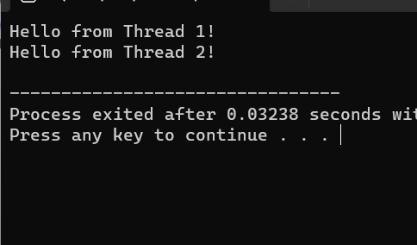

1. **Design a C program to simulate the concept of Dining-Philosophers problem**

## AIM :

To design a C program to simulate the concept of Dining-Philosophers problem

## PROGRAM :

#include <stdio.h> #include <stdlib.h> #include <pthread.h> #include <unistd.h>

#define NUM_PHILOSOPHERS 5

pthread_mutex_t chopsticks[NUM_PHILOSOPHERS];

void* philosopherLifeCycle(void* arg) { int id = *((int*)arg);

int left_chopstick = id;

int right_chopstick = (id + 1) % NUM_PHILOSOPHERS;

while (1) {

// Think

printf("Philosopher %d is thinking...\n", id);

// Pick up chopsticks pthread_mutex_lock(&chopsticks[left_chopstick]); pthread_mutex_lock(&chopsticks[right_chopstick]);

// Eat

printf("Philosopher %d is eating...\n", id); sleep(rand() % 3 + 1); // Eating time

// Put down chopsticks pthread_mutex_unlock(&chopsticks[left_chopstick]); pthread_mutex_unlock(&chopsticks[right_chopstick]);

// Repeat the cycle

}

}

int main() {

pthread_t philosophers[NUM_PHILOSOPHERS]; int philosopher_ids[NUM_PHILOSOPHERS];

// Initialize mutex locks

for (int i = 0; i < NUM_PHILOSOPHERS; ++i) {

pthread_mutex_init(&chopsticks[i], NULL);

}

// Create philosopher threads

for (int i = 0; i < NUM_PHILOSOPHERS; ++i) {

philosopher_ids[i] = i;

pthread_create(&philosophers[i], NULL, philosopherLifeCycle, (void*)&philosopher_ids[i]);

}

// Wait for threads to finish (although they run indefinitely) for (int i = 0; i < NUM_PHILOSOPHERS; ++i) {

pthread_join(philosophers[i], NULL);

}

// Destroy mutex locks

for (int i = 0; i < NUM_PHILOSOPHERS; ++i) {

pthread_mutex_destroy(&chopsticks[i]);

}

return 0;

}

Output: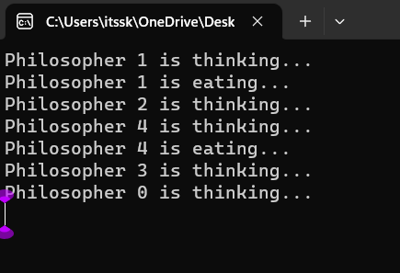

**13.Construct a C program to implement various memory allocation strategies.**

## AIM :

To construct a C program to implement various memory allocation strategies.

## PROGRAM :

#include<stdio.h>

void bestfit(int mp[],int p[],int m,int n){ int j=0;

for(int i=0;i<n;i++){

if(mp[i]>p[j]){

printf("\n%d fits in %d",p[j],mp[i]);

mp[i]=mp[i]-p[j++]; i=i-1;

}

}

for(int i=j;i<m;i++)

{

printf("\n%d must wait for its process",p[i]);

}

}

void rsort(int a[],int n){ for(int i=0;i<n;i++){

for(int j=0;j<n;j++){

if(a[i]>a[j]){

void sort(int a[],int n){ for(int i=0;i<n;i++){

for(int j=0;j<n;j++){

if(a[i]<a[j]){

}

}

}

}

void firstfit(int mp[],int p[],int m,int n){ sort(mp,n);

sort(p,m); bestfit(mp,p,m,n);

}

void worstfit(int mp[],int p[],int m,int n){ rsort(mp,n);

sort(p,m); bestfit(mp,p,m,n);

}

int main(){

int m,n,mp[20],p[20],ch; printf("Number of memory partition : "); scanf("%d",&n);

printf("Number of process : "); scanf("%d",&m);

printf("Enter the memory partitions : \n"); for(int i=0;i<n;i++){

scanf("%d",&mp[i]);

}

printf("ENter process size : \n"); for(int i=0;i<m;i++){

scanf("%d",&p[i]);

}

## printf("1. Firstfit\t2. Bestfit\t3. worstfit\nEnter your choice : "); scanf("%d",&ch);

bestfit(mp,p,m,n); break;

case 2:

firstfit(mp,p,m,n); break;

case 3:

worstfit(mp,p,m,n); break;

default:

printf("invalid"); break;

}

}

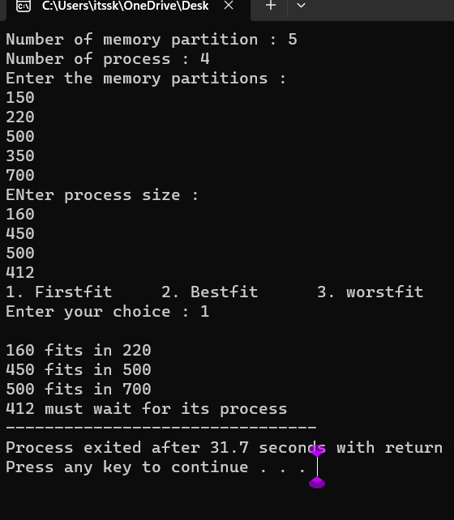

**14. Construct a C program to organize the file using single level directory**

## AIM:

To construct a c program to organize the file using single level directory

## PROGRAM :

#include <stdio.h> #include <stdlib.h> #include <fcntl.h> #include <unistd.h>

#define BUFFER_SIZE 4096 void copy(){

const char *sourcefile= "C:/Users/itssk/OneDrive/Desktop/sasi.txt";

const char *destination_file="C:/Users/itssk/OneDrive/Desktop/sk.txt"; int source_fd = open(sourcefile, O_RDONLY);

int dest_fd = open(destination_file, O_WRONLY | O_CREAT | O_TRUNC, 0666);

char buffer[BUFFER_SIZE]; ssize_t bytesRead, bytesWritten;

while ((bytesRead = read(source_fd, buffer, BUFFER_SIZE)) > 0) { bytesWritten = write(dest_fd, buffer, bytesRead);

}

close(source_fd); close(dest_fd);

printf("File copied successfully.\n");

}

void create()

{

char path[100];

FILE *fp; fp=fopen("C:/Users/itssk/OneDrive/Desktop/sasi.txt","w"); printf("file created successfully");

}

int main(){

int n;

printf("1. Create \t2. Copy \t3. Delete\nEnter your choice: " ); scanf("%d",&n);

switch(n){

remove("C:/Users/itssk/OneDrive/Desktop/sasi.txt"); printf("Deleted successfully");

}}

output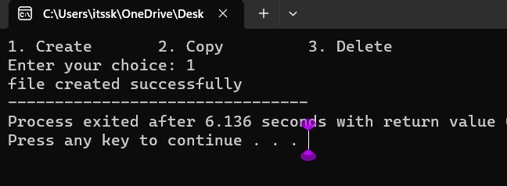

**14. Design a C program to organize the file using two level directory structure**

**Aim:**

## To design a C program to organize the file using two level directory structure

## PROGRAM :

#include <stdio.h>

#include <stdlib.h>

#include<string.h> int main() {

char mainDirectory[] = "C:/Users/itssk/OneDrive/Desktop"; char subDirectory[] = "os";

char fileName[] = "example.txt"; char filePath[200];

char mainDirPath[200];

snprintf(mainDirPath, sizeof(mainDirPath), "%s/%s/", mainDirectory, subDirectory);

snprintf(filePath, sizeof(filePath), "%s%s", mainDirPath, fileName); FILE *file = fopen(filePath, "w");

if (file == NULL) { printf("Error creating file.\n"); return 1;

}

fprintf(file, "This is an example file content."); printf("File created successfully: %s\n");

}

Output:

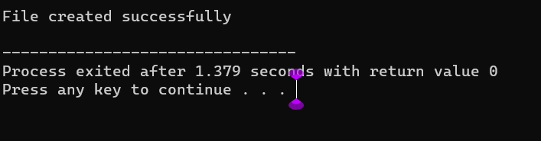

**16.Develop a C program for implementing random access file for processing the employee details**

## AIM :

To develop a C program for implementing random access file for processing the employee details

## PROGRAM :

#include <stdio.h> #include <stdlib.h> struct Employee {

int empId;

char empName[50]; float empSalary;};

int main() { FILE *filePtr;

struct Employee emp;

filePtr = fopen("employee.dat", "rb+"); if (filePtr == NULL) {

filePtr = fopen("employee.dat", "wb+"); if (filePtr == NULL) {

printf("Error creating the file.\n"); return 1; }

}

int choice; do {

printf("\nEmployee Database Menu:\n"); printf("1. Add Employee\n");

printf("2. Display Employee Details\n"); printf("3. Update Employee Details\n"); printf("4. Exit\n");

printf("Enter your choice: "); scanf("%d", &choice); switch (choice) {

case 1:

printf("Enter Employee ID: "); scanf("%d", &emp.empId); printf("Enter Employee Name: ");

scanf("%s", emp.empName); printf("Enter Employee Salary: "); scanf("%f", &emp.empSalary);

fseek(filePtr, (emp.empId - 1) * sizeof(struct Employee), SEEK_SET);

fwrite(&emp, sizeof(struct Employee), 1, filePtr); printf("Employee details added successfully.\n"); break;

case 2:

printf("Enter Employee ID to display: "); scanf("%d", &emp.empId);

fseek(filePtr, (emp.empId - 1) * sizeof(struct Employee), SEEK_SET);

fread(&emp, sizeof(struct Employee), 1, filePtr); printf("Employee ID: %d\n", emp.empId); printf("Employee Name: %s\n", emp.empName); printf("Employee Salary: %.2f\n", emp.empSalary); break;

case 3:

printf("Enter Employee ID to update: "); scanf("%d", &emp.empId);

fseek(filePtr, (emp.empId - 1) * sizeof(struct Employee), SEEK_SET);

fread(&emp, sizeof(struct Employee), 1, filePtr); printf("Enter Employee Name: ");

scanf("%s", emp.empName); printf("Enter Employee Salary: "); scanf("%f", &emp.empSalary);

fseek(filePtr, (emp.empId - 1) * sizeof(struct Employee), SEEK_SET);

fwrite(&emp, sizeof(struct Employee), 1, filePtr); printf("Employee details updated successfully.\n"); break;

case 4:

break; default:

printf("Invalid choice. Please try again.\n");

}

} while (choice != 4); fclose(filePtr);

return 0;

**output:**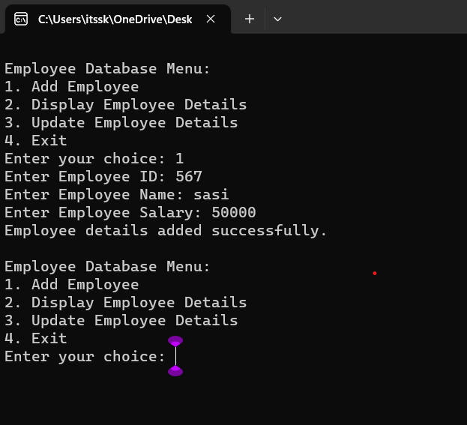

**17.Illustrate the deadlock avoidance concept by simulating Banker’s algorithm using C.**

## AIM :

To illustrate the deadlock avoidance concept by simulating Banker’s algorithm using C.

## PROGRAM :

#include <stdio.h>

#define MAX_PROCESSES 5

#define MAX_RESOURCES 3 int is_safe();

int available[MAX_RESOURCES] = {3, 3, 2}; // Available instances of each resource

int maximum[MAX_PROCESSES][MAX_RESOURCES] = {{7, 5, 3},

{3, 2, 2}, {9, 0, 2}, {2, 2, 2}, {4, 3, 3}};

int allocation[MAX_PROCESSES][MAX_RESOURCES] = {{0, 1, 0},

{2, 0, 0}, {3, 0, 2}, {2, 1, 1}, {0, 0, 2}};

int request_resources(int process_num, int request[]) {

// Check if request can be granted

for (int i = 0; i < MAX_RESOURCES; i++) {

if (request[i] > available[i] || request[i] > maximum[process_num][i]

- allocation[process_num][i])

return 0; // Request cannot be granted

}

// Try allocating resources temporarily

for (int i = 0; i < MAX_RESOURCES; i++) { available[i] -= request[i];

allocation[process_num][i] += request[i];

// Update maximum and need matrix if request is granted maximum[process_num][i] -= request[i];

}

// Check if system is in safe state after allocation if (is_safe()) {

return 1; // Request is granted

} else {

// Roll back changes if not safe

for (int i = 0; i < MAX_RESOURCES; i++) { available[i] += request[i]; allocation[process_num][i] -= request[i]; maximum[process_num][i] += request[i];

}

return 0; // Request is denied

}

}

int is_safe() {

int work[MAX_RESOURCES];

int finish[MAX_PROCESSES] = {0};

// Initialize work array

for (int i = 0; i < MAX_RESOURCES; i++) { work[i] = available[i];

}

// Check if processes can finish int count = 0;

while (count < MAX_PROCESSES) { int found = 0;

for (int i = 0; i < MAX_PROCESSES; i++) { if (finish[i] == 0) {

int j;

for (j = 0; j < MAX_RESOURCES; j++) {

if (maximum[i][j] - allocation[i][j] > work[j]) break;

}

if (j == MAX_RESOURCES) {

// Process can finish, update work and mark as finished for (int k = 0; k < MAX_RESOURCES; k++) {

work[k] += allocation[i][k];

}

finish[i] = 1;

found = 1; count++;

}

}

}

if (found == 0) {

return 0; // No process can finish, not safe state

}

}

return 1; // All processes can finish, safe state

}

int main() {

int process_num, request[MAX_RESOURCES]; printf("Enter process number (0 to 4): "); scanf("%d", &process_num);

printf("Enter resource request (e.g., 0 1 0): "); for (int i = 0; i < MAX_RESOURCES; i++) {

scanf("%d", &request[i]);

}

if (request_resources(process_num, request)) { printf("Request granted.\n");

} else {

printf("Request denied. System is not in safe state.\n");

}

return 0;

## output:

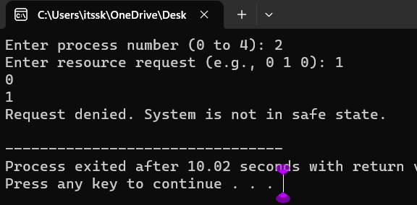

**18.Construct a C program to simulate producer consumer problem using semaphores.**

## AIM :

To construct a C program to simulate producer consumer problem using semaphores.

## PROGRAM :

#include <stdio.h> #include <pthread.h> #include <semaphore.h> #include<Windows.h>

#define BUFFER_SIZE 5

#define MAX_ITEMS 10 // Maximum number of items to be produced/consumed

int buffer[BUFFER_SIZE]; sem_t empty, full;

int produced_items = 0, consumed_items = 0;

void* producer(void* arg) {

while (produced_items < MAX_ITEMS) { sem_wait(&empty);

// Critical section: add item to buffer

for (int i = 0; i < BUFFER_SIZE; ++i) { if (buffer[i] == 0) {

buffer[i] = produced_items + 1; printf("Produced: %d\n", buffer[i]);

produced_items++; break;

}

}

sem_post(&full);

Sleep(1); // Sleep for a while

}

return NULL;

}

void* consumer(void* arg) {

while (consumed_items < MAX_ITEMS) { sem_wait(&full);

// Critical section: remove item from buffer for (int i = 0; i < BUFFER_SIZE; ++i) {

if (buffer[i] != 0) {

printf("Consumed: %d\n", buffer[i]); buffer[i] = 0;

consumed_items++; break;

}

}

sem_post(&empty); Sleep(2); // Sleep for a while

}

return NULL;

}

int main() {

pthread_t producer_thread, consumer_thread;

sem_init(&empty, 0, BUFFER_SIZE);

sem_init(&full, 0, 0);

// Create producer and consumer threads pthread_create(&producer_thread, NULL, producer, NULL); pthread_create(&consumer_thread, NULL, consumer, NULL);

// Wait for threads to finish pthread_join(producer_thread, NULL); pthread_join(consumer_thread, NULL);

// Destroy semaphores sem_destroy(&empty); sem_destroy(&full);

return 0;

}

## OUTPUT :

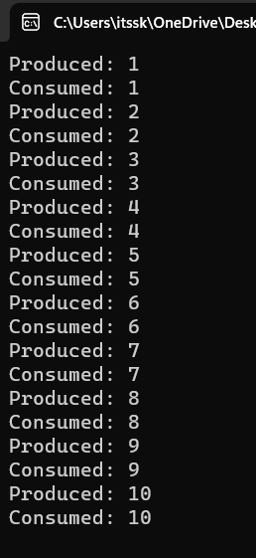

19. **Design a C program to implement process synchronization using mutex locks.**

## AIM:

To design a C program to implement process synchronization using mutex locks

## PROGRAM :

#include <stdio.h> #include <pthread.h>

// Shared variables int counter = 0;

pthread_mutex_t mutex;

// Function to be executed by threads void *threadFunction(void *arg) {

int i;

for (i = 0; i < 1000000; ++i) { }

return NULL;

}

int main() {

pthread_mutex_init(&mutex, NULL); pthread_t thread1, thread2;

pthread_create(&thread1, NULL, threadFunction, NULL); pthread_create(&thread2, NULL, threadFunction, NULL);

// Wait for the threads to finish pthread_join(thread1, NULL); pthread_join(thread2, NULL);

// Destroy the mutex pthread_mutex_destroy(&mutex);

// Print the final value of the counter printf("Final counter value: %d\n", counter);

return 0;

}

Output: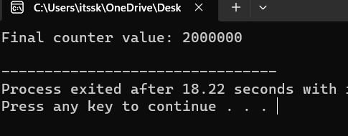

**20. Construct a C program to simulate Reader-Writer problem using semaphores**

## AIM :

**To Construct a C program to simulate Reader-Writer problem using semaphores**

## PROGRAM :

#include <stdio.h> #include <pthread.h> #include <semaphore.h>

sem_t mutex, writeBlock;

int data = 0, readersCount = 0;

void *reader(void *arg) { int i=0;

while (i<10) { sem_wait(&mutex); readersCount++;

if (readersCount == 1) { sem_wait(&writeBlock);

}

sem_post(&mutex);

// Reading operation

printf("Reader reads data: %d\n", data);

sem_wait(&mutex); readersCount--;

if (readersCount == 0) { sem_post(&writeBlock);

}

sem_post(&mutex);

sem_post(&mutex);

i++;

}

}

void *writer(void *arg) { int i=0;

while (i<10) { sem_wait(&writeBlock);

// Writing operation data++;

printf("Writer writes data: %d\n", data);

sem_post(&writeBlock); i++;

}

}

int main() {

pthread_t readers, writers; sem_init(&mutex, 0, 1);

sem_init(&writeBlock, 0, 1); pthread_create(&readers, NULL, reader, NULL); pthread_create(&writers, NULL, writer, NULL); pthread_join(readers, NULL); pthread_join(writers, NULL); sem_destroy(&mutex);

sem_destroy(&writeBlock);

return 0;

}

**Output:**

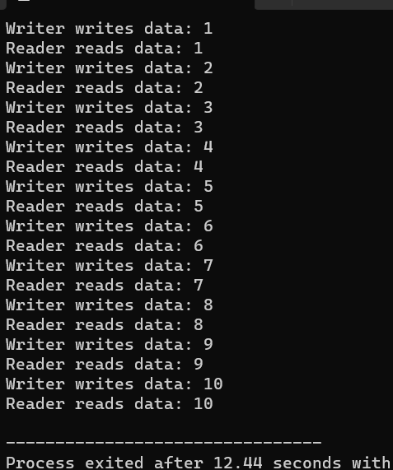

# **21.** Develop a C program to implement worst fit algorithm of memory management.

**Aim:**

To Develop a C program to implement worst fit algorithm of memory management.

## PROGRAM:

#include <stdio.h>

#define MAX_MEMORY 1000 int memory[MAX_MEMORY];

// Function to initialize memory void initializeMemory() {

for (int i = 0; i < MAX_MEMORY; i++) {

memory[i] = -1; // -1 indicates that the memory is unallocated

}

}

// Function to display memory status void displayMemory() {

int i, j;

int count = 0; printf("Memory Status:\n");

for (i = 0; i < MAX_MEMORY; i++) {

if (memory[i] == -1) { count++;

j = i;

while (memory[j] == -1 && j < MAX_MEMORY) { j++;

}

printf("Free memory block %d-%d\n", i, j - 1); i = j - 1;

}

}

if (count == 0) {

printf("No free memory available.\n");

}

}

// Function to allocate memory using worst-fit algorithm void allocateMemory(int processId, int size) {

int start = -1;

int blockSize = 0;

for (int i = 0; i < MAX_MEMORY; i++) { if (memory[i] == -1) {

if (blockSize == 0) { start = i;

}

blockSize++;

} else {

blockSize = 0;

}

if (blockSize >= size) {

break;

}

}

if (blockSize >= size) {

for (int i = start; i < start + size; i++) { memory[i] = processId;

}

printf("Allocated memory block %d-%d to Process %d\n", start, start + size - 1, processId);

} else {

printf("Memory allocation for Process %d failed (not enough contiguous memory).\n", processId);

}

}

// Function to deallocate memory

void deallocateMemory(int processId) {

for (int i = 0; i < MAX_MEMORY; i++) { if (memory[i] == processId) {

memory[i] = -1;

}

}

printf("Memory released by Process %d\n", processId);

}

int main() { initializeMemory(); displayMemory();

allocateMemory(1, 200); displayMemory();

allocateMemory(2, 300); displayMemory();

deallocateMemory(1); displayMemory();

allocateMemory(3, 400); displayMemory();

return 0;

}

Output: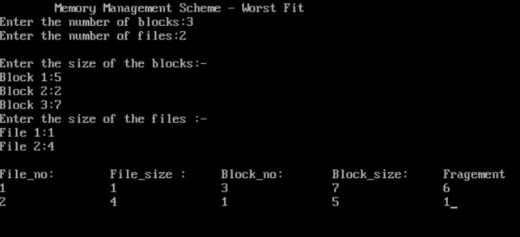

# 21.Construct a C program to implement best fit algorithm of memory management.

**AIM:**

TO Construct a C program to implement best fit algorithm of memory management.

## PROGRAM:

#include <stdio.h>

#define MAX_MEMORY 1000 int memory[MAX_MEMORY];

// Function to initialize memory void initializeMemory() {

for (int i = 0; i < MAX_MEMORY; i++) {

memory[i] = -1; // -1 indicates that the memory is unallocated

}

}

// Function to display memory status void displayMemory() {

int i, j;

int count = 0; printf("Memory Status:\n");

for (i = 0; i < MAX_MEMORY; i++) {

if (memory[i] == -1) { count++;

j = i;

while (memory[j] == -1 && j < MAX_MEMORY) { j++;

}

printf("Free memory block %d-%d\n", i, j - 1); i = j - 1;

}

}

if (count == 0) {

printf("No free memory available.\n");

}

}

// Function to allocate memory using best-fit algorithm void allocateMemory(int processId, int size) {

int start = -1;

int blockSize = MAX_MEMORY; int bestStart = -1;

int bestSize = MAX_MEMORY;

for (int i = 0; i < MAX_MEMORY; i++) { if (memory[i] == -1) {

if (blockSize == MAX_MEMORY) { start = i;

}

blockSize++;

} else {

if (blockSize >= size && blockSize < bestSize) { bestSize = blockSize;

bestStart = start;

}

blockSize = 0;

}

}

if (bestSize >= size) {

for (int i = bestStart; i < bestStart + size; i++) { memory[i] = processId;

}

printf("Allocated memory block %d-%d to Process %d\n", bestStart, bestStart + size - 1, processId);

} else {

printf("Memory allocation for Process %d failed (not enough contiguous memory).\n", processId);

}

}

// Function to deallocate memory

void deallocateMemory(int processId) {

for (int i = 0; i < MAX_MEMORY; i++) { if (memory[i] == processId) {

memory[i] = -1;

}

}

printf("Memory released by Process %d\n", processId);

}

int main() { initializeMemory(); displayMemory();

allocateMemory(1, 200); displayMemory();

allocateMemory(2, 300); displayMemory();

deallocateMemory(1); displayMemory();

allocateMemory(3, 400); displayMemory();

return 0;

}

OUTPUT:

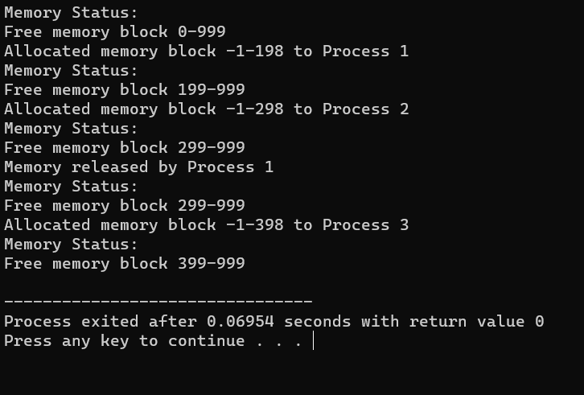

# 23. Construct a C program to implement first fit algorithm of memory management.

AIM:

TO Construct a C program to implement first fit algorithm of memory management.

## PROGRAM:

#include <stdio.h>

#define MAX_MEMORY 1000 int memory[MAX_MEMORY];

// Function to initialize memory void initializeMemory() {

for (int i = 0; i < MAX_MEMORY; i++) {

memory[i] = -1; // -1 indicates that the memory is unallocated

}

}

// Function to display memory status void displayMemory() {

int i, j;

int count = 0; printf("Memory Status:\n");

for (i = 0; i < MAX_MEMORY; i++) {

if (memory[i] == -1) { count++;

j = i;

while (memory[j] == -1 && j < MAX_MEMORY) { j++;

}

printf("Free memory block %d-%d\n", i, j - 1); i = j - 1;

}

}

if (count == 0) {

printf("No free memory available.\n");

}

}

// Function to allocate memory using first-fit algorithm void allocateMemory(int processId, int size) {

int start = -1;

int blockSize = 0;

for (int i = 0; i < MAX_MEMORY; i++) { if (memory[i] == -1) {

if (blockSize == 0) { start = i;

}

blockSize++;

} else {

blockSize = 0;

}

if (blockSize >= size) { break;

}

}

if (blockSize >= size) {

for (int i = start; i < start + size; i++) { memory[i] = processId;

}

printf("Allocated memory block %d-%d to Process %d\n", start, start + size - 1, processId);

} else {

printf("Memory allocation for Process %d failed (not enough contiguous memory).\n", processId);

}

}

// Function to deallocate memory

void deallocateMemory(int processId) {

for (int i = 0; i < MAX_MEMORY; i++) { if (memory[i] == processId) {

memory[i] = -1;

}

}

printf("Memory released by Process %d\n", processId);

}

int main() { initializeMemory(); displayMemory();

allocateMemory(1, 200); displayMemory();

allocateMemory(2, 300); displayMemory();

deallocateMemory(1); displayMemory();

allocateMemory(3, 400); displayMemory();

return 0;

}

**OUTPUT:**

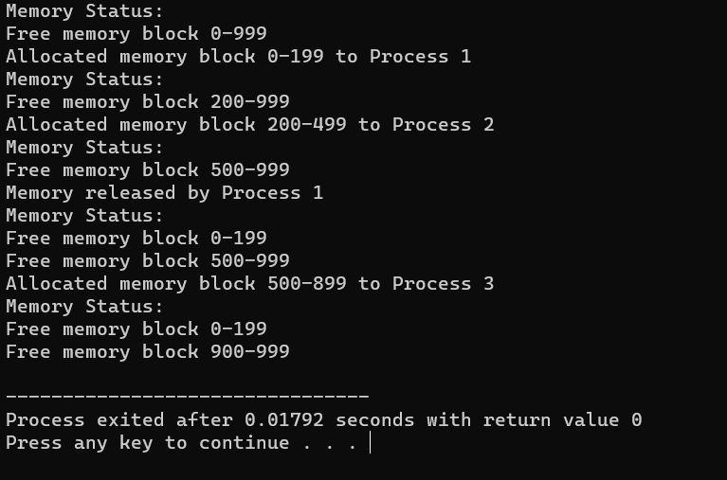

# **24.** Design a C program to demonstrate UNIX system calls for file management.

## AIM:

# To Design a C program to demonstrate UNIX system calls for file management.

## PROGRAM:

#include <stdio.h> #include <stdlib.h> #include <unistd.h> #include <fcntl.h> #include <sys/types.h> #include <sys/stat.h>

int main() { int fd;

char buffer[100];

// Creating a new file

fd = creat("sample.txt", S_IRWXU); if (fd == -1) {

perror("create"); exit(1);

} else {

printf("File 'sample.txt' created successfully.\n"); close(fd);

}

// Opening an existing file for writing

fd = open("sample.txt", O_WRONLY | O_APPEND); if (fd == -1) {

perror("open"); exit(1);

} else {

printf("File 'sample.txt' opened for writing.\n");

}

// Writing data to the file write(fd, "Hello, World!\n", 14);

printf("Data written to 'sample.txt'.\n"); close(fd);

// Opening the file for reading

fd = open("sample.txt", O_RDONLY); if (fd == -1) {

perror("open"); exit(1);

} else {

printf("File 'sample.txt' opened for reading.\n");

}

// Reading data from the file

int bytesRead = read(fd, buffer, sizeof(buffer)); if (bytesRead == -1) {

perror("read"); exit(1);

} else {

printf("Data read from 'sample.txt':\n"); write(STDOUT_FILENO, buffer, bytesRead);

}

close(fd);

// Deleting the file

if (remove("sample.txt") == -1) { perror("remove");

exit(1);

} else {

printf("File 'sample.txt' deleted.\n");

}

Return 0; }

**OUTPUT:**

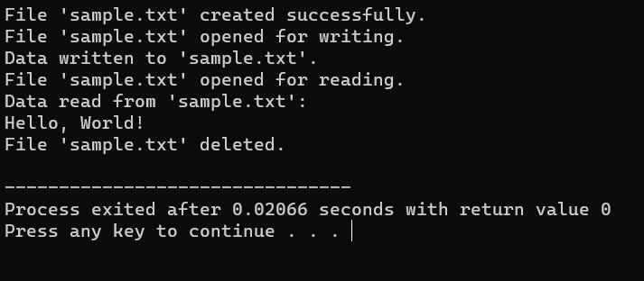

# 25. Construct a C program to implement the I/O system calls of UNIX (fcntl, seek, stat, opendir, readdir)

**AIM:**

To Construct a C program to implement the I/O system calls of UNIX (fcntl, seek, stat, opendir, readdir)

## PROGRAM:

#include<stdio.h> #include<fcntl.h> #include<errno.h> extern int errno; int main()

{

int fd = open("foo.txt", O_RDONLY | O_CREAT); printf("fd = %d\n", fd);

if (fd ==-1)

{

printf("Error Number % d\n", errno); perror("Program");

}

return 0;

}

OUTPUT:

